ILIAS Task Template
- Preliminary Note
The goal of this template is to assist you in describing the tasks in your course in a consistent manner.
- Elements of a task description
  - Task Number
To keep your students orientated it is helpful to number your tasks successively.
  - Task Title
A concise task title motivates your students and makes the task easier to identify.
  - Introductory Text
The introductory text gives gives context and leads the students towards their activities.
  - Your Activities
In this section you should list in a very concise and clear way all the activities students have to undertake to fulfil the task. (Questions that should be answered: What do I have to do? Until when? How will I receive feedback? etc.) If there is more than one activity, they should be numbered, too.
  - Resources
Please list the type and filename of all digital ressources that belong to this task (Video URLs or files, PDFs, other documents, etc.)
- Example
This is an example of a task description:

Task Number
1
Task Title
What does it mean to be a nurse?
Introductory text
In honor of National Nurses Week, Stanford Health Care nurses talk about why they became a nurse, what being a nurse means to them, what type of person becomes a nurse, and why they love their job.

Your Activities
- Watch the video carefully
- Take notes about what these nurses described as important to being a nurse.
- In the video the nurses talked about many things which they felt were important, but they did not include education as a major topic. Consult your notes which describe what these nurses considered were important and then respond to this statement on the discussion board.

Resources
Video (YouTube): https://youtu.be/gTi1t5J0i2E?si=Jo5sfz-zdnRTS2V6

- Implementation of a task description in ILIAS:
This screenshot shows you how the task that has been described above could look like in ILIAS:
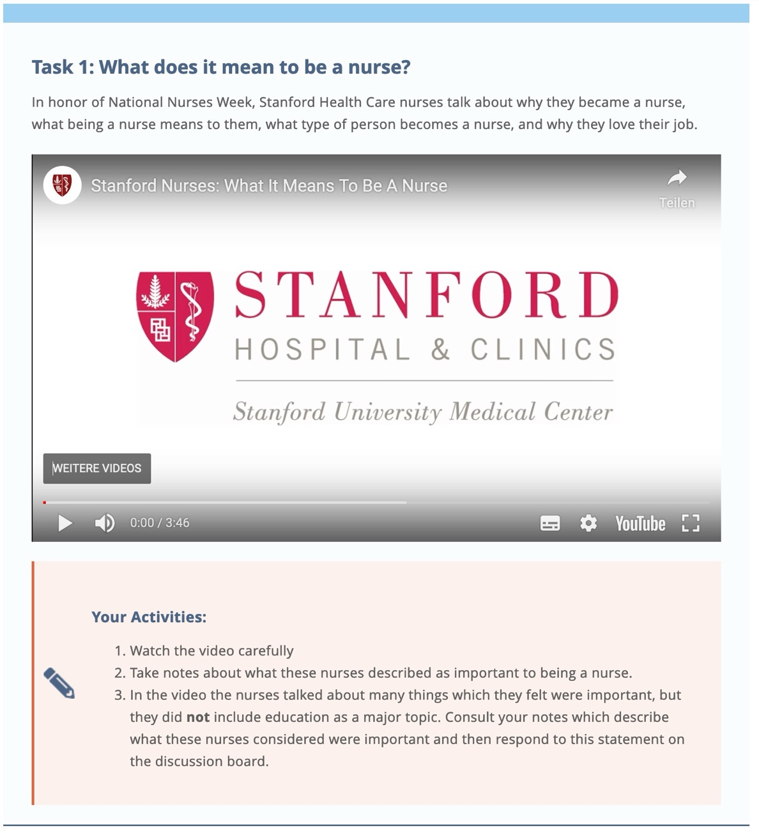

- Copy-paste task template
- - - - - -
Task Number

Task Title

Introductory text

Your Activities

Resources

- - - - -

